Meeting Minutes –Group 1

**Meeting No:** 1

**Location:** Room 111

**Date:** 9 September 2015

**Time:** 45 minutes

**Reporter**: Nguyễn Trung Nam

## Attendance

1. Kiều Trọng Khánh
2. Huỳnh Quang Thảo
3. Trần Thanh Ngoan
4. Nguyễn Trung Nam
5. Ngô Tiến Đạt

## Action Items

1. **Capstone Plan**

* w1d2: introduction, fix scope.
* w2d1: project plan.
* w2d2 – w4d1: SRS/coding.
* w4d2 – w6d2: coding(verify).
* w7 – w10: coding and SDD.
* w11 – w12: rehearsal, coding and testing.
* w12 – w13: document, complete.
* w14: coding, modifying, presentation.

1. **Core Scope:**
2. 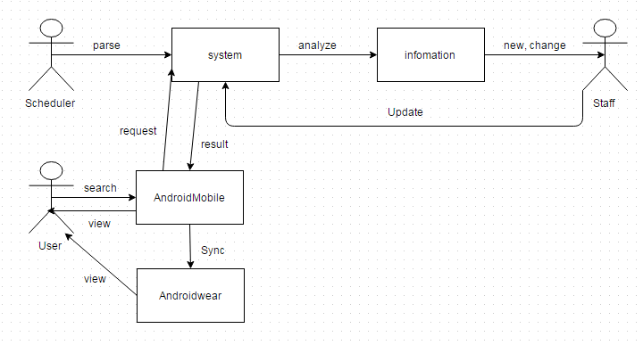**Discussion about scope:**
3. **Discussion about algorithm.**

* Best distance of two point.
* Best distance of four point:
  + One point starts, one point ends and random two point.
  + One point starts, unknown point ends of three.

1. **Next meeting: Friday, 11 September, 2015**

* Introduction.
* Fix scope.

|  |  |  |  |
| --- | --- | --- | --- |
| Owner | Item | Deadline | Status |
| Thảo | Review Document. Review Use case diagram | Friday | In progress |
| Ngoan | Report 1. Review Use case diagram | Friday | In progress |
| Nam | Report 1. Review Use case diagram | Friday | In progress |
| Đạt | Report 1. Review Use case diagram | Friday | In progress |

**Other Notes:**

* How to auto collect information of bus routes when web change?
* Should user save history on mobile or wear?